import matplotlib.pyplot as plt

instagram_hours = [1, 2, 3, 4, 2.5, 5, 3.5, 6, 4.5, 2]
posts_per_month = [4, 6, 10, 12, 8, 18, 13, 20, 15, 7]

plt.scatter(instagram_hours, posts_per_month)

plt.xlabel("Hours Spent on Instagram per Day")
plt.ylabel("Posts Uploaded per Month")
plt.title("Instagram Usage vs Posts Uploaded")

plt.show()
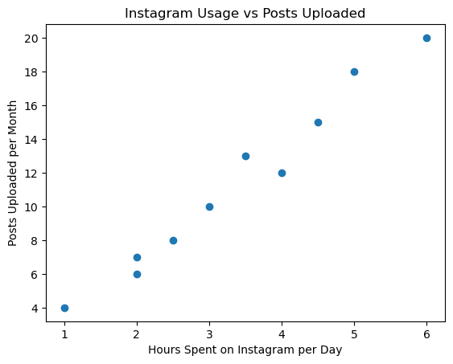
import matplotlib.pyplot as plt

names = [
'Aman', 'Riya', 'Neha', 'Rahul', 'Simran', 'Karan',
'Pooja', 'Arjun', 'Meera', 'Vikas', 'Anjali', 'Rohit'
]

orders = [5, 8, 4, 10, 7, 12, 6, 9, 3, 11, 7, 5]

amount_spent = [
1500, 2800, 1200, 3500, 2200, 4200,
1800, 3000, 900, 3800, 2300, 1600
]

plt.scatter(orders, amount_spent)

for i in range(len(names)):
plt.annotate(names[i], (orders[i], amount_spent[i]))

plt.xlabel("Number of Zomato Orders")
plt.ylabel("Amount Spent")
plt.title("Zomato Orders vs Amount Spent")

plt.show()
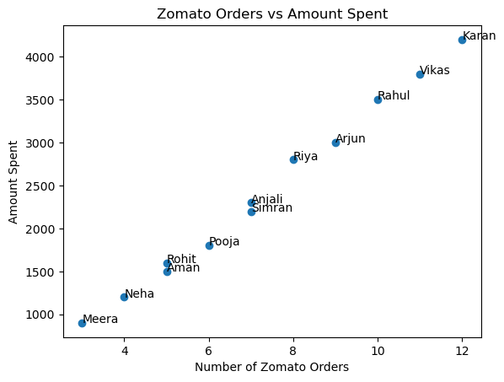
import matplotlib.pyplot as plt
import numpy as np

orders = np.array([5, 8, 4, 10, 7, 12, 6, 9, 3, 11, 7, 5])

amount_spent = np.array([
1500, 2800, 1200, 3500, 2200, 4200,
1800, 3000, 900, 3800, 2300, 1600
])

plt.scatter(orders, amount_spent)

slope, intercept = np.polyfit(orders, amount_spent, 1)

trend_line = slope * orders + intercept

plt.plot(orders, trend_line)

plt.xlabel("Number of Zomato Orders")
plt.ylabel("Amount Spent")
plt.title("Zomato Orders vs Amount Spent with Trend Line")

plt.show()
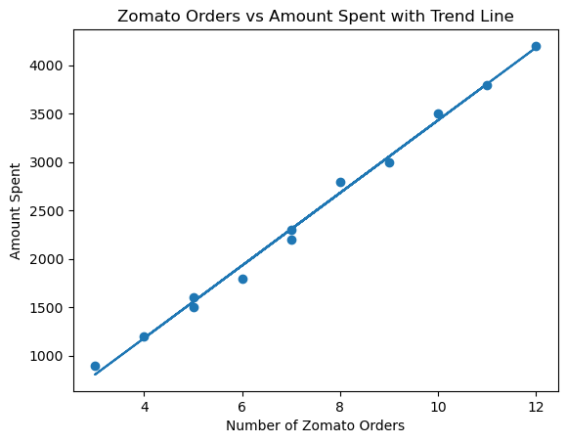
import matplotlib.pyplot as plt
import numpy as np

youtube_hours = np.array([
2, 3, 1, 4, 5, 2.5, 6, 3.5, 4.5, 1.5,
5.5, 2, 6.5, 3, 4
])

spotify_hours = np.array([
1.5, 2, 1, 3, 3.5, 2, 4, 2.5, 3, 1.2,
4, 1.8, 4.5, 2.2, 3.2
])

plt.scatter(youtube_hours, spotify_hours)

slope, intercept = np.polyfit(
youtube_hours,
spotify_hours,
1
)

trend_line = slope * youtube_hours + intercept

plt.plot(youtube_hours, trend_line)

equation = f"y = {slope:.2f}x + {intercept:.2f}"

plt.text(0.5, 4.2, equation)

plt.xlabel("YouTube Watch Hours")
plt.ylabel("Spotify Listening Hours")
plt.title("YouTube vs Spotify Usage")

plt.show()
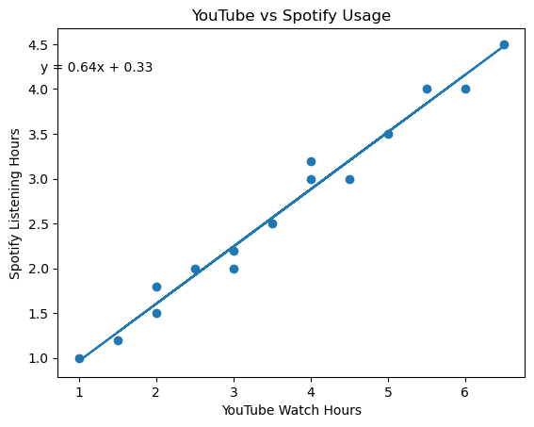
import matplotlib.pyplot as plt
import numpy as np

orders = np.array([2, 4, 3, 6, 5, 8, 7, 10, 9, 12])

total_amount = np.array([
1500, 3200, 2400, 5000, 4200,
6800, 5900, 8500, 7600, 10000
])

plt.scatter(orders, total_amount)

slope, intercept = np.polyfit(orders, total_amount, 1)

trend_line = slope * orders + intercept

plt.plot(orders, trend_line)

plt.xlabel("Number of Flipkart Orders")
plt.ylabel("Total Amount Spent")
plt.title("Flipkart Orders vs Total Amount Spent")

plt.show()
